**core difference between Playwright E2E tests and Jest/Jasmine unit tests** lies in **what they test and how they interact with your Angular app.**

* Playwright **doesn't build or serve your Angular app.**
* It **only opens the app in the browser and performs UI interactions.**

Either run ng serve in another terminal

Or

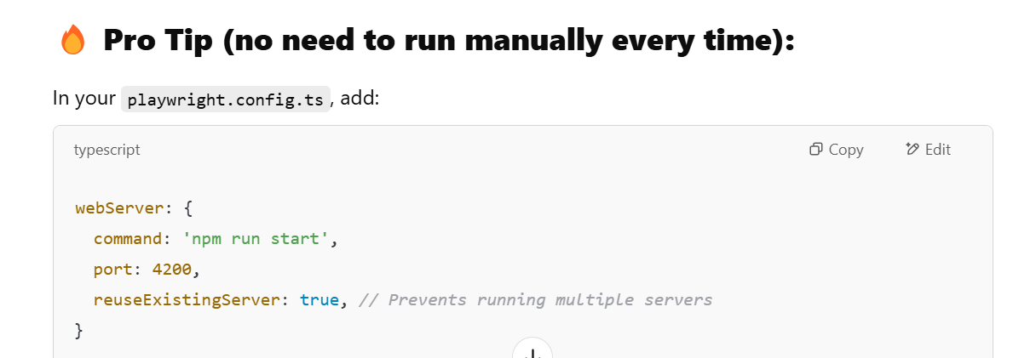

Playwright will **start Angular app automatically**, run tests, and **shut it down after tests complete. 🚀**

**✅ Playwright E2E Test (End-to-End Test)**

* Tests **how your Angular app behaves in the browser**.
* It **opens your app in a real browser** (like Chromium, Firefox, or WebKit).
* Simulates **real user actions like clicking, navigation, form filling**, etc.
* Validates **UI elements, page navigation, and external links (like Allure Report)**.
* **Catches integration issues between components**, API calls, and routing.

(from this example.spec.ts)

* Opens Angular app in the browser
* Clicks on the "Home" link
* Checks if the URL is updated

**Jest/Jasmine Unit Test**

* Tests **individual Angular components or services in isolation**.
* Does **not run in a browser** (uses **Node.js environment**).
* Mocks dependencies like services, API calls, and child components.
* Focuses on **business logic and function outputs**.
* Runs much **faster** since there is **no browser interaction**.

(from counterservice file)

* Testing **service logic directly**.
* No browser interaction or UI testing.

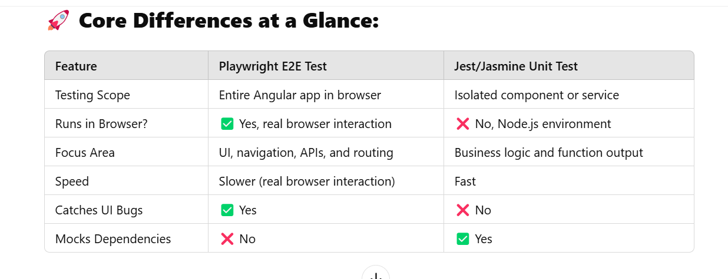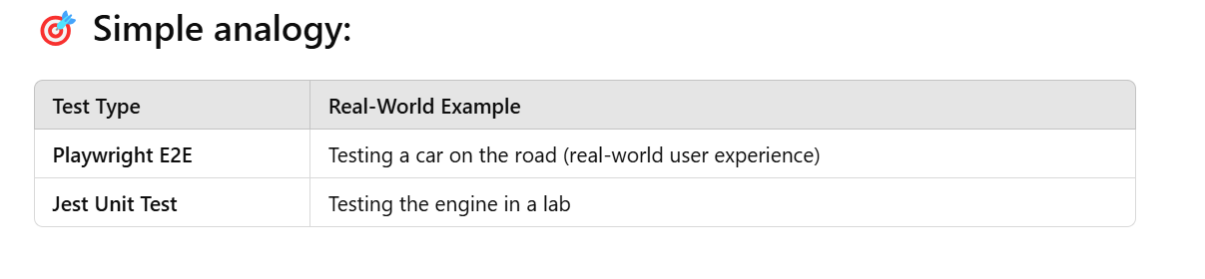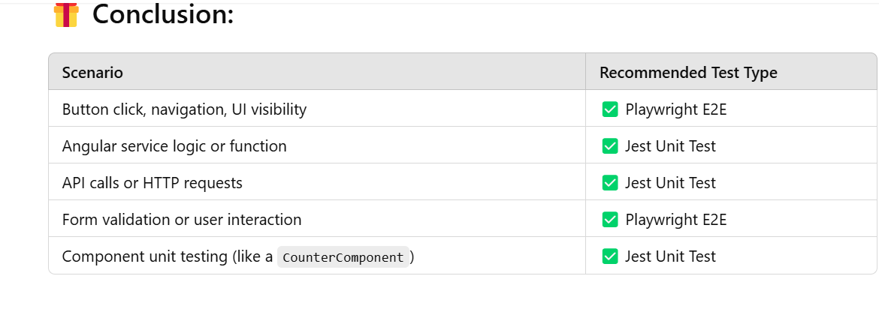

Ah! That's because **Playwright runs in ****** **headless mode by default** (without opening the browser).

✅ To see the browser while running Playwright tests:

npx playwright test –headed

**Or, update your playwright.config.ts:**

In playwright.config.ts file, add this:

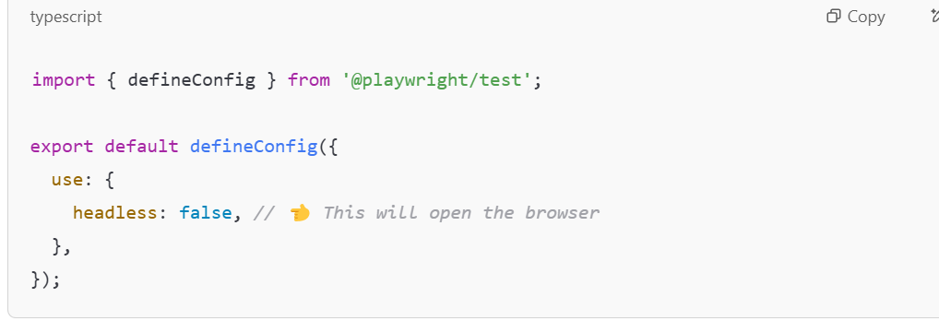

**Bonus Tip:**

If you want **slow motion** to **see each step slowly**, add this:

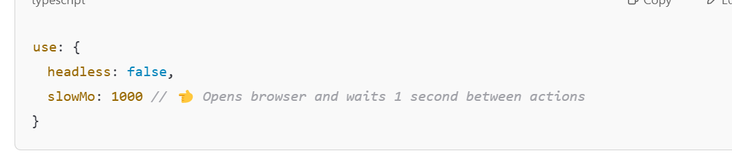

**Output you'll see now:**

* Opens Angular app at http://localhost:4200
* Clicks "Home" link
* Navigates to Allure Report
* Checks if "Hello" message is visible